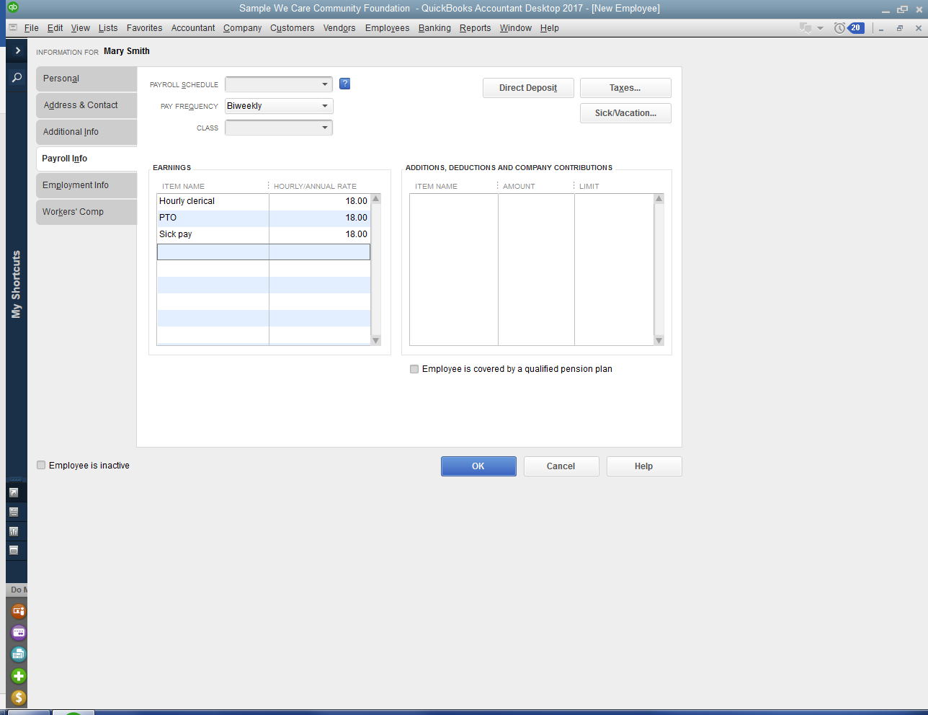
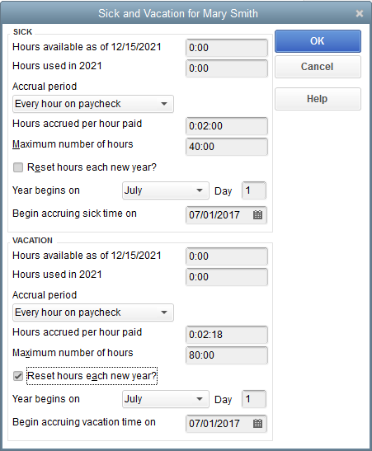
To switch to a calendar year, change the year to January 1 before the first payroll in January.
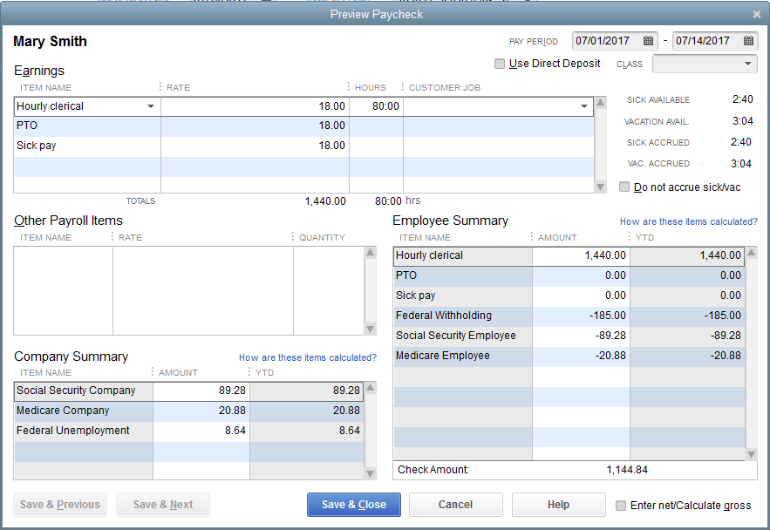
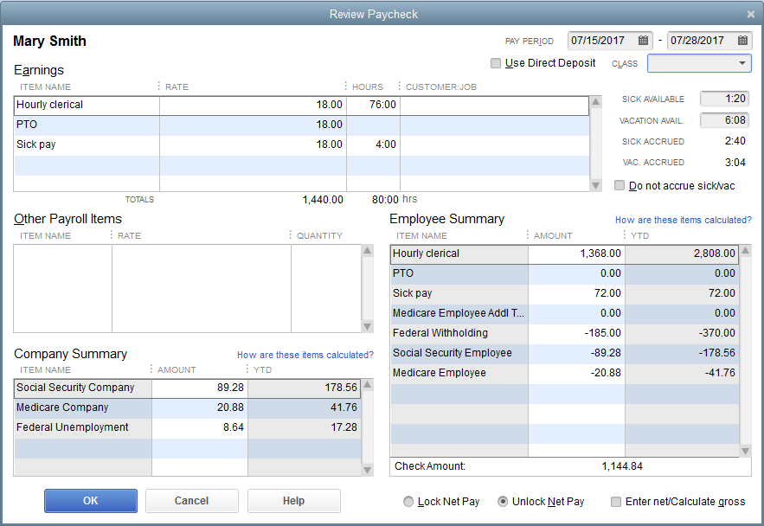
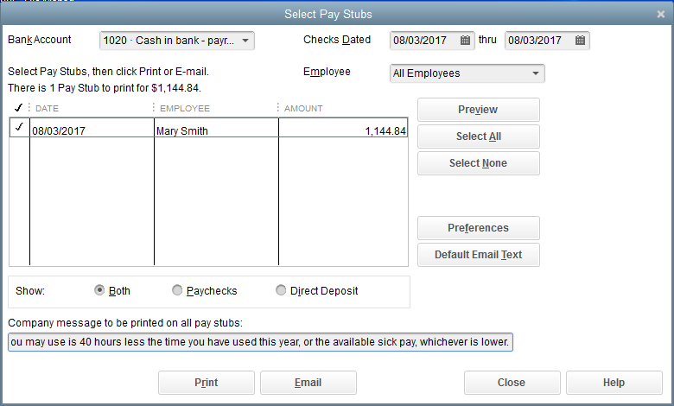
Sick pay is limited to 40 hours/year. “Sick pay available” time may include time that you are not eligible to use. The time you may use is 40 hours less the “YTD used” time, or the available sick pay time, whichever is lower.

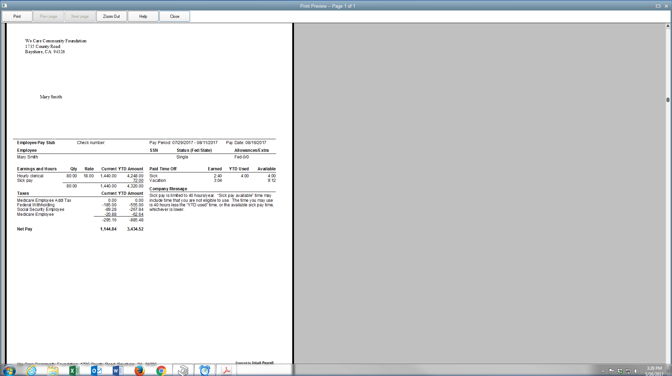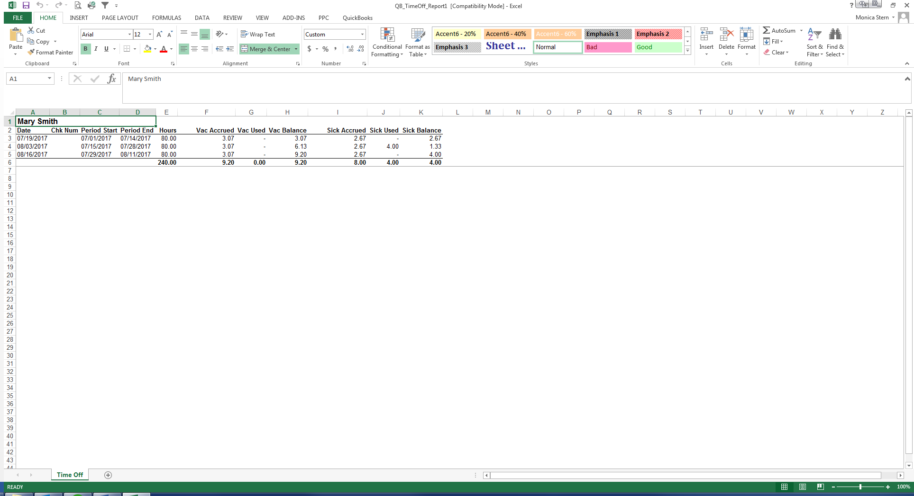
Employee accrual for 07/01/2017 to 06/30/2018
Name | Actual hours worked | Sick hours accrued | Sick hours used | Balance of Accrued hours | Hours available to start next year
Employee #1 | 2080 | 40 | 0 | 40 | 40
Employee accrual for 07/01/2018 to 06/30/2019
Employee #1 | 2080 | 40 | 2 | 78 | 40
How to communicate to employee that accrued hours may be more than available hours?

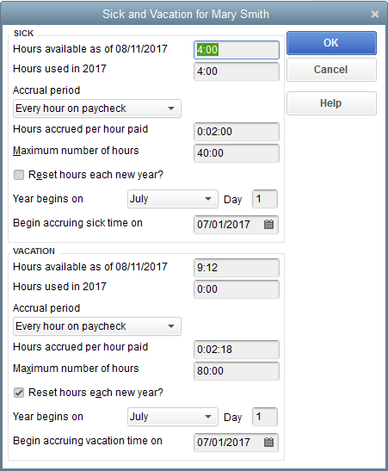
To carry-over the proper number of hours into year two – manually adjust the “maximum number of hours” to be equal to the carryover at year end plus the maximum accrual for the next year. Do this before running first payroll of the new year. Example, set to 68 if employee has 28 in carryover plus can earn up to 40 hours in the next year. Must adjust on an employee-by-employee basis.

